Design Document:

Record Label Building

Purpose:
The purpose of this web site will be to provide knowledge on starting a record label from the ground up without a large financial backing. The site will also contain links and other information to assist visitors in their goal of running their own music companies or becoming an independent artist.

Audience:
The target audience will be anyone that is between the ages of 18 and 40. The target audience would be mostly made up of persons who have an interest in the business of music. The age range was chosen because a person needs to be 18 or have a partner that is 18 to open a business bank account.

Needs Assessment:
I explained the concept of the web site to five people that I know have been thinking about starting up record label companies. I sent out text messages and emails asking what would be the portion of the website that would be most useful to them as musical content creators.
Questions asked to potential web site observers:
- Do you know what a record label is?
- Do you know how to get started?
- Do you know how money works record label wise?
- Why do you want to start a label?
- Do you know how to properly release music?
- What do you want to learn the most about starting a label?
Summary of the content that was mostly requested to be met in regard to the website:
After comparing the responses that were received from those that were interviewed, the topics that were found to be the most consistently requested were cost, protection, business license, forms, and copyright information. Everyone also wants a step by step process to follow that will allow them to get setup to conduct business as a record label. After evaluating the interviews I have chosen to split the site up into the following areas. Those areas will be getting started, developing works, getting paid, legal info, forms, promotion, and links.
Reference websites
These sites are sites that I have decided to use as references for the following aspects of the web site.
- Navigation: https://performingarts.withgoogle.com/en_us
I believe that navigation should be simple so that the visitor can easily move back and forth between pages without any hassle.
- Layout: https://www.codecademy.com/stories
I like the minimalist design for the website, and I will try to imply the same strategy.
- Color Scheme: I created a custom color scheme online.
The scheme I generated can be found at the following link
https://coolors.co/04080f-788496-2283e5-0c315b-dae3e5

Content:
I previously stated that I would focus on the following areas, and dedicate a page for each area of the website.
- Getting Started: This area of the web site will focus on educating the audience about the purpose of a record label, obtaining a business license, opening bank accounts, tax id numbers, needed documents, costs, and a few other important items that need to be completed in order to get the record label off the ground.
- Developing Works: This section will explain the importance of developing new music, and the needed steps to release the music to an audience. I will also discuss how to develop a plan to save costs while developing musical works.
- Getting Paid: I will provide information about the various ways of receiving payment for musical works, and what a company or artist needs to do to make sure they are able to receive money for their hard work and efforts.
- Legal Info: In this section I will describe what must be done in order to comply with the law. I will also provide links to forms and web resources to help the audience acquire other information that falls into the legal category as well.
- Forms: This section of the website will contain links to important forms and websites that contain those forms. This section of the site will also include a small description of the forms purpose.
- Links: This portion of the website will contain a list of potentially useful information to our audience in relation to a variety of topics.

Media:
I will provide all of the photographs for the web site. If I decide to use any outside media sources, then I will cite the resource and give full credit. All of the media that I create and post will not for use without written permission. I will create an image using Adobe Photoshop and or my camera that will be displayed on each page that will be relevant to the material on the page.

Color scheme and rationale:
I decided that the following color scheme would be a good fit for my site. I plan on the banner being black with white text, and the footer being the darker blue with white text. The headings will be gray with white text, and the body of the page will be the lighter blue swatch. My color scheme was created online and can be found at the following link. https://coolors.co/04080f-788496-2283e5-0c315b-dae3e5
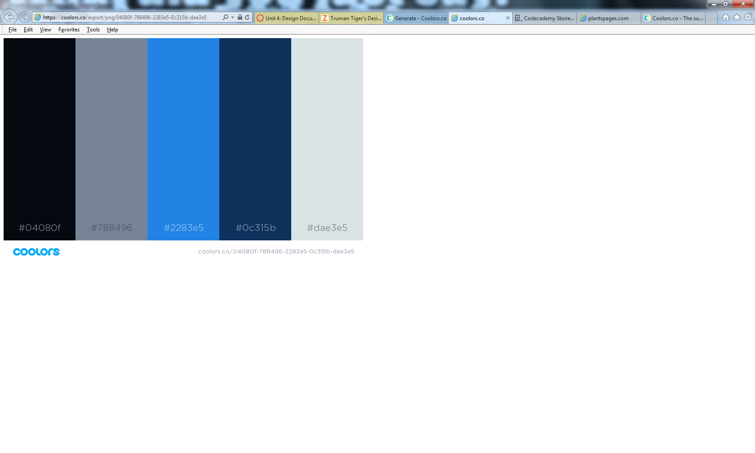

Web Site Outline:
The following information is an outline of the website. The navigation bar will contain a link to the Home page.
- Home Page
  - Banner with logo
  - Featured image
  - Navigation bar with links to all pages
  - Introduction to site
  - Contact information including name and email address link in footer area
  - Last revised date
- Getting Started
  - Banner with logo
  - Navigation bar with links to all pages
  - Featured image
  - Record Label Company Structure
  - Selecting A Name
  - Registering Your Company
  - Opening A Business Bank Account
  - Employer Identification Number
  - Tax ID Number
  - Independent Artist Or Independent Record Label?
  - Navigation bar with links to all pages
  - Contact information including name and email address link in footer area
  - Last revised date
- Developing Works
  - Banner with logo
  - Featured image
  - Navigation bar with links to all pages
  - Music Production
  - Artist Development
  - Vision And Growth
  - Costs and Budgeting
  - Contact information including name and email address link in footer area
  - Last revised date
- Getting Paid
  - Banner with logo
  - Featured image
  - Navigation bar with links to all pages
  - Protection
  - Selling And Licensing
  - Performing Arts Societies
  - Sources Of Income
  - Copyright Information
  - Paying Others
  - Accounting
  - Methods Of Transaction
  - Contact information including name and email address link in footer area
  - Last revised date
- Legal Info
  - Banner with logo
  - Featured image
  - Navigation bar with links to all pages
  - Information that describes in detail specific items that will need to be completed and maintained to keep the record label legit
  - Links to resources that may be needed to complete required items by audience
  - Agreements and contract information
  - Tax information
  - Contact information including name and email address link in footer area
  - Last revised date
- Forms
  - Banner with logo
  - Featured image
  - Navigation bar with links to all pages
  - List of hyperlinks to various forms, resources, and files that the audience may need
  - Contact information including name and email address link in footer area
  - Last revised date
- Links
  - Banner with logo
  - Featured image
  - List of hyperlinks and resources for audience to use as needed
  - Navigation bar with links to all pages
  - Contact information including name and email address link in footer area
  - Last revised date

Web Site Wire Frame:
I have constructed my wireframe for the web site and it can be viewed by selecting the link below.
http://atr555.neocities.org/islt_4360/Design_Document/wire%20frame%20label%20builder.pdf

